Design Model Report of

UET official website
Version <1.0>

Prepared by
Group 9

Trần Quang Tín
Ngô Minh Trí
Nguyễn Bình Nguyên
Lê Anh Quân

Instructor: | Dr. Dang Duc Hanh
Course: | Software Engineering 2016
Date: | 03/12/2016

Table of Contents
Contents
1.Introduction 4
1.1 Purpose 4
1.2 References 4
2.Design Model 4
2.1 Identify the object classes in the system 4
2.2 Choose the design model. 5
2.2.1 The use case: Login 6
6
2.2.2 The use case: Home page 7
2.2.3 The use case: Read Article 8
2.2.4 The use case: Comment 9

Introduction

1.1 Purpose
The purpose of this report is to present a detailed description on the Design Model of the UET official website. This document is for both the stakeholders and the developers of the system.

1.2 References
The report was completed following the book and documentation recommended and provided by Dr. Dang Duc Hanh including:
- The textbook Software Engineering 9th Edition written by Sommerville
- The series of lectures and slides of Software Engineering Course 2016 provided by Dr. Dang Duc Hanh.

Design Model

2.1 Identify the object classes in the system

From the requirements documenting stage, we determine what is the object classes in the system. Then, we also identify the attributes and operations or methods for each class from the description of the system requirements documentation.

There are 3 object classes in the system as shown in the following figures.

Genre
- genreId
- name
- namewithoutDiacriticMarks
+ getGenreID()
+ getGenreList()

User
- userID
- name
- email
- quyen
- password
+ getUserID()
+ login()
+ logout()
+ comment()
+ readArticle()
Article
- articleId
- name
- namewithoutDiacriticMarks
+ getArticleID()
+ getSubGenreId()
+ getArticleList()
SubGenre
- subGenreID
- name
- namewithoutDiacriticMarks
+ getSubGenreID()
+ getGenreID()
+ getSubGenreList()

2.2 Choose the design model.
In this project, we harness the design models in our system for showing the associations and relationships between the object classes in the system. The design model utilized in this project is waterfall model, which describe the structure of the system and show the interactions between the system objects. The model is the bridge connecting the system requirements and the implementation of the project together.

We use UML to describe and visualize the interactions between the objects of the system by deploying the sequence model. Below are the significant use cases of the system where the users play the role of main actors.

2.2.1 The use case: Login
Description of Use Case:
The users log in to the system using their account and password.

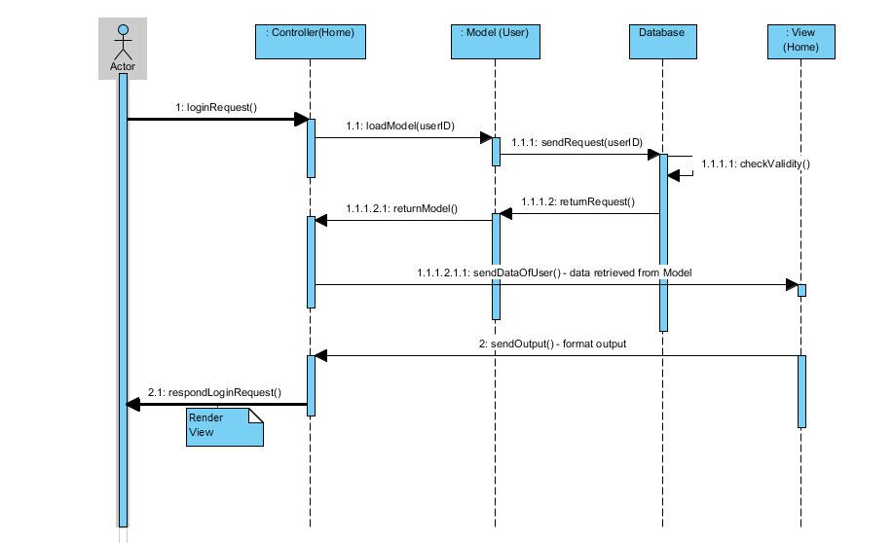
Figure 1 Login Use Case - Sequence Diagram

First, the users send a login request to the controller, it passes to model to achieve the data from from the database. After that, the model returns the data to the model and then, the controller loads the view with the data retrieved which is the response to the login request.

2.2.2 The use case: Home page

Description of Use Case:
The users view the list of all genres

First, the users send a request to the controller, it asks the model for the genres data from the database. After that, the model returns the data and the controller loads the view with the data retrieved which is the reply to the view genres request.

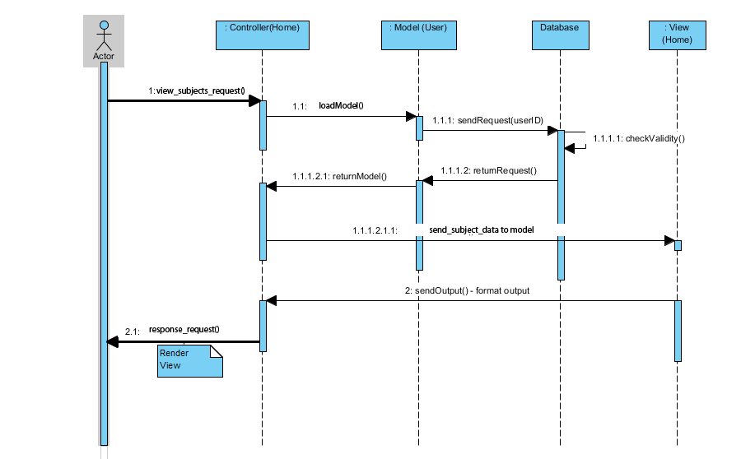
Figure 2 View Subjects Use Case - Sequence Diagram

2.2.3 The use case: Read Article

2.2.4 The use case: Comment

